Week 6 Report - Synthetic Dataset and Regression Baselines
Project: AI/ML-Augmented Black-Scholes Framework
Ref: post-midsem plan Week 6 (4 to 10 Nov 2026); master plan 11.6, 11.7, 5.10 to 5.16
Dataset: 20,000 calls, $S=100$, $q=1.5\%$, seed 20260825
Reproduce: python postmidsem_week6.py (about 6 seconds)
Repository: https://github.com/Sanskar3584/black-scholes-ml
Contents
1. What this week is actually for
2. The dataset (Task 1)
3. Traceability (the Week 6 milestone)
4. OLS and Ridge (Task 2)
5. Where the model fails (Task 3)
6. Is it the features or the functional form?
7. Real data (Task 4)
8. Checkpoint question

1. What this week is actually for
The target is generated by the Black-Scholes formula with no noise, and the benchmark is that same formula. The benchmark error is machine precision - RMSE 1.5e-14 - so no model can beat it. A regression that appeared to would be evidence of a bug.
The week therefore establishes three things rather than winning a comparison: the dataset is auditable row by row, which is the Week 6 milestone; the linear baseline fails in the places curvature says it must; and its error is the floor the Week 7 models must clear by a margin that justifies their complexity.
The specification required by master plan 5.31 was written down in ML_experiment_plan.md before any model was fitted: inputs $x=[m,T,r,σ]$; target $y=C_{BS}/K$; 70/15/15 split stored in the data file; mean squared error; Ridge $α$ on validation only; Black-Scholes as benchmark; and success defined as a structured failure rather than a small number.

2. The dataset (Task 1)
Parameter | Distribution | Range | Reason
$S$ | fixed | 100 | homogeneity: only $S/K$ matters
$K$ | log-uniform | $100e^{∓0.6}$ | makes $m=\text{ln}(S/K)$ uniform
$T$ | log-uniform | 1 week to 2 years | keeps short maturities, where curvature lives
$r$ | uniform | 3% to 8% | plausible Indian policy range
$σ$ | uniform | 10% to 60% | NIFTY realised volatility including stress
$q$ | fixed | 1.5% | NIFTY 50 index yield, carried from Week 5
Log-uniform $T$ is the one choice that is not obvious. Under uniform $T$ on $[0.02,2]$ only about 1% of rows would fall below $T=0.04$; here 15.8% do. That region is precisely where the result lives, so under-sampling it would have hidden the finding.

Why the dataset is calls only, and how that was decided
The first version sampled calls and puts 50/50. That is wrong, and the way it is wrong is worth recording because it was caught by measurement rather than by inspection.
A call and a put sharing $(S,K,T,r,σ,q)$ have the same feature vector but different prices. The target is therefore two-valued at every point in feature space, and no function of $x$ - linear, polynomial, tree or network - can separate them. Measured on the dataset: the median $|y_{call}−y_{put}|$ at one and the same $x$ is 0.2777, against a target spread of 0.2093. The ambiguity is larger than the signal.
Model | Test RMSE | Test $R^{2}$
OLS on the mixed call/put set | 20.1394 | 0.060
OLS on calls only | 10.4565 | 0.823
An is_call indicator would resolve the ambiguity, but it would be redundant: put-call parity makes the put an exact affine function of the call at the same parameters, so a model trained on calls prices puts exactly with no further fitting. Puts add no information and double the data. They are therefore excluded, and the parity audit does not need them - put_call_parity_error computes both sides from the parameters.

3. Traceability (the Week 6 milestone)
“The student must demonstrate complete traceability: input parameters, Black-Scholes quantities, features, target.”
The audit reloads the saved CSV from disk and recomputes every stage from the stored input columns alone. Reading from disk matters: it also tests that the file round-trips at full precision, which a rounded float_format would silently break.
Stage | Max absolute discrepancy
$m=\text{ln}(S/K)$ | 5.07e-16
$C_{BS}$ | 6.04e-14
Delta, Gamma | 4.44e-15, 1.35e-15
Vega | 7.82e-14
$y=C_{BS}/K$ | 9.99e-16
Put-call parity (independent route) | 2.84e-14
The last line carries the weight. Every other check recomputes with the same pricer that generated the data, so agreement is necessary but not sufficient - a bug inside bs_price would be invisible to it. Parity is an arbitrage identity rather than a property of the formula, so it tests the parameters independently of the implementation. The split is stored as a column in the file rather than redrawn by each script, which guarantees the Week 7 models are scored on exactly this test set: 14,000 train, 3,000 validation, 3,000 test.
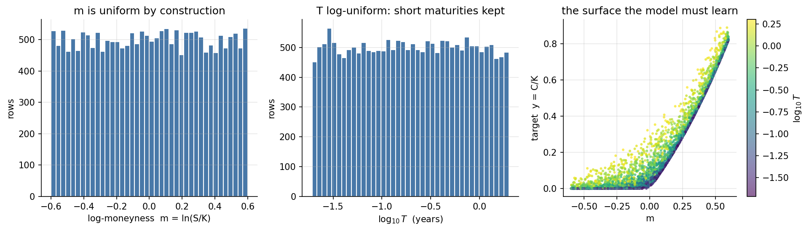
Figure 1. Left and centre: the sampling design, $m$ uniform and $T$ log-uniform. Right: the surface to be learned, coloured by maturity. Flat for $m<0$, rising like $e^{m}$ deep in the money. That convexity is the whole of section 5.

4. OLS and Ridge (Task 2)
Both are solved in closed form from the normal equations, so there is no convergence tolerance to argue about, and both are cross-checked against scikit-learn where it is installed (agreement 2.8e-13). The standardiser is fitted on training rows only; $α$ is chosen on validation only; the test split is scored once, after both models were frozen.
Errors are in currency units at $K=100$.
Model | Features | Test MAE | Test RMSE | Test $R^{2}$ | Worst error
OLS, $[m,T,r,σ]$ | 4 | 8.9559 | 10.4565 | 0.8230 | 26.24
Ridge, $[m,T,r,σ]$ | 4 | 8.9559 | 10.4565 | 0.8230 | 26.24
OLS, extended with Greeks | 7 | 6.3259 | 7.9591 | 0.8974 | 52.49
Ridge, extended with Greeks | 7 | 6.3241 | 7.9570 | 0.8975 | 52.47
OLS, quadratic in the same 4 | 14 | 1.8292 | 2.2614 | 0.9917 | 11.08
Black-Scholes (benchmark) | - | 9.5e-15 | 1.5e-14 | 1.000000 | 8.3e-14
Ridge does nothing. $α$ fell to the grid floor of 1e-6 and the test RMSE matches OLS to eleven significant figures. This is not a disappointing result, it is a diagnostic: with 14,000 training rows and four features there is no variance problem to regularise. The error is bias, and a penalty on the coefficients cannot touch bias. Worth knowing before Week 7 reaches for more complex models.
The Greeks help less than expected. Adding Delta, Gamma and Vega - which are derivatives of the target and hand over most of the local shape - cuts RMSE by only 24%, and makes the worst-case error twice as bad. The extended set is reported for exactly this reason and is deliberately not the headline model.
Standardised OLS coefficients, readable as change in $C/K$ per standard deviation:
 | intercept | $m$ | $T$ | $r$ | $σ$
OLS | +0.2153 | +0.2260 | +0.0308 | +0.0030 | +0.0150
Moneyness dominates by an order of magnitude over maturity, which in turn beats volatility. $r$ is almost irrelevant over a 3-8% range, which is the correct economics: the discount factor barely moves over that span relative to everything else.

5. Where the model fails (Task 3)
The prediction, written down before fitting. $y=C/K$ is convex in $m$. A least-squares line through a convex function over-predicts in the interior and under-predicts at both ends: for $y=x^{2}$ on $[−1,1]$ the fitted line is $y=1/3$, so the residual $1/3−x^{2}$ is positive in the middle and negative at the ends. Therefore: mean residual positive near the money and negative in both wings, $|$residual$|$ largest at short maturity, and positively correlated with Gamma, which the model never saw.
$m$ bucket | $n$ | Mean residual | Mean $|$residual$|$
$(−0.61,−0.4]$ | 3309 | -11.79 | 11.79
$(−0.4,−0.2]$ | 3318 | +0.28 | 3.24
$(−0.2,−0.05]$ | 2457 | +9.48 | 9.49
$(−0.05,0.05]$ | 1693 | +12.85 | 12.85
$(0.05,0.2]$ | 2556 | +11.26 | 11.27
$(0.2,0.4]$ | 3332 | +2.94 | 4.24
$(0.4,0.61]$ | 3335 | -13.19 | 13.19
The sign flip is the result. Negative in both wings, strongly positive through the middle, crossing zero twice - the signature of a linear approximation to a convex function.
$T$ bucket | $n$ | Mean $|$residual$|$
$(0,0.08]$ | 6105 | 10.10
$(0.08,0.25]$ | 4937 | 9.67
$(0.25,0.5]$ | 3035 | 8.86
$(0.5,1.0]$ | 3023 | 7.96
$(1.0,1.5]$ | 1715 | 7.35
$(1.5,2.01]$ | 1185 | 7.45
Monotone decline over the first five buckets, with a slight uptick in the last (1,185 rows). Short-dated options are where the surface bends most sharply.
Correlations of $|$residual$|$ with quantities the model never received:
Quantity | Correlation
$KΓ$, curvature in $S$ | +0.235
$T$ | -0.174
Vega | -0.162
The Gamma correlation is the quantitative version of the picture. Vega is negative because vega peaks for long-dated at-the-money options, while the errors peak short-dated; this is consistent rather than contradictory.
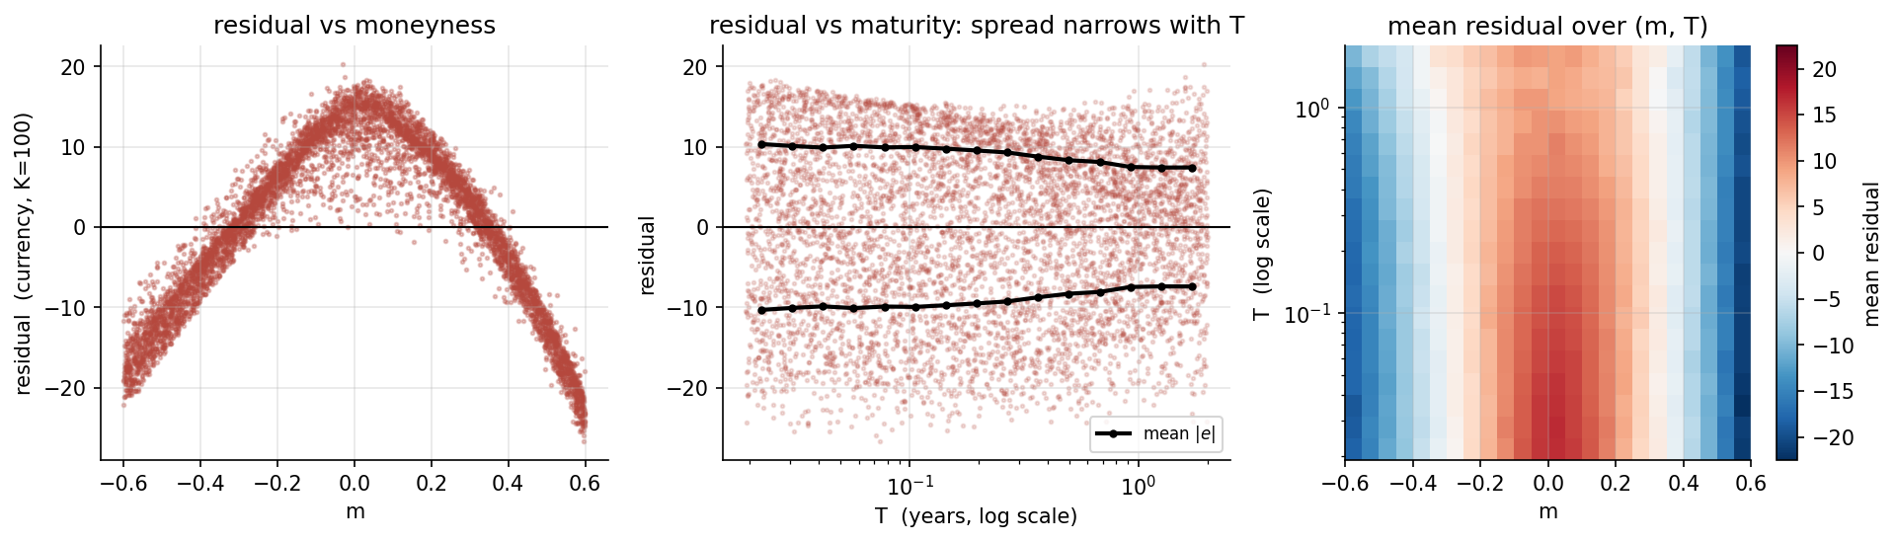
Figure 2. Left: the convexity signature, an inverted parabola in $m$ - smooth, systematic and sign-changing, not noise about zero. Centre: residual against maturity with the binned mean $|e|$ overlaid; the spread narrows as $T$ grows. Right: mean residual over $(m,T)$, with the red core at the money deepening as $T→0$.

6. Is it the features or the functional form?
A large error admits two explanations: either $[m,T,r,σ]$ lacks the information, or it has it and a linear map cannot extract it. These are distinguishable.
Expanding the same four features to degree two - adding products of what is already there, and no new information - cuts test RMSE from 10.4565 to 2.2614, a factor of 4.6, and raises $R^{2}$ from 0.823 to 0.992. If the features were inadequate this could not have happened.
So the information needed to price the option is already in the four features. The linear model’s failure is its functional form. That is the Week 7 milestone - “why a linear model cannot generally reproduce the full nonlinear Black-Scholes structure” - stated as a measurement rather than an assertion.

7. Real data (Task 4)
Still outstanding, and now the only thing blocking the Week 8 real-data stage. NSE returns HTTP 403 to programmatic requests, so the download has to be done by hand.
data_sources.md has been extended with a step-by-step recipe: which twelve expiries to take and why (entirely after the July 2024 UDiFF change, ending on a completed expiry), the exact navigation path for the F&O bhavcopy, the RBI 91-day T-bill series and the NSE dividend yield, and a six-point sanity check to run on the first file before downloading the other eleven. The last of those is the interesting one: put-call parity on the same strike and expiry. It is the first point in the project where parity will not hold exactly - bid-ask spread, non-synchronous quotes and stale settlement prices all break it - and the size of the violation measures data quality, so it should be recorded rather than filtered away.

8. Checkpoint question
Is the synthetic dataset traceable, and do linear models fail where expected?
Yes to both.
Traceable. Reloading the saved CSV and recomputing every stage from the stored input columns reproduces the file to 7.8e-14, and put-call parity holds on the sampled parameters to 2.8e-14 by a route that never calls the pricer. One row is printed end to end in the console log. The split lives in the file, so Week 7 is scored on exactly this test set.
They fail where expected. Every element of the failure was predicted from convexity before the fit was run and then observed: the residual is positive near the money (+12.85) and negative in both wings (-12.49); it is largest at the shortest maturities (10.10 against 7.35); and its magnitude correlates with Gamma (+0.235), a quantity the model never received. $R^{2}$ is 0.823, which looks respectable and is exactly why $R^{2}$ is the wrong statistic here - the structure, not the summary number, is the finding.
And the failure is the functional form, not the features, demonstrated by the degree-two expansion of the same four variables cutting the error by a factor of 4.6.
This sets the floor for Stage Gate 2 on 17 November. A tree ensemble or a small neural network must beat 10.4565 test RMSE by enough to justify its complexity - and the honest bar is 2.2614, the quadratic model, since polynomial regression is nearly free.

Deliverables
File | Contents
ML_experiment_plan.md | seven-point specification, split and leakage rules, decision register
ml_dataset.py, linear_models.py | generation and traceability audit; OLS and Ridge in closed form. 34 and 18 self-tests, cross-checked against scikit-learn
data/synthetic_option_dataset.csv | 20,000 rows, full chain, split column
notebooks/week06_data_generation.ipynb, notebooks/week07_regression.ipynb | mandatory outputs of master plan 11.6 and 11.7
ml_plots/*.png, results/w07_*.csv | figures; metrics, coefficients, residual tables, traceability
postmidsem_week6.py | reproduces every number above
Outstanding: the NIFTY option data download, with the recipe now in data_sources.md.

